Ideation Phase
Brainstorm & Idea Prioritization

Date | 2 january 2026
Team ID
Project Name | TheBookStop – Online Bookstore Platform
Maximum Marks | 4 Marks
Brainstorm & Idea Prioritization
Brainstorming provides a free and open environment that encourages all team members to actively participate in the creative thinking process. It promotes collaboration, idea-sharing, and innovative problem-solving. During this phase, emphasis is placed on generating a wide range of ideas without immediate judgment, allowing creativity to flow freely.
This brainstorming activity helped the team conceptualize TheBookStop, an online bookstore platform designed to simplify book discovery, purchasing, and management for users, sellers, and administrators.

Step 1: Team Gathering, Collaboration, and Problem Statement Selection
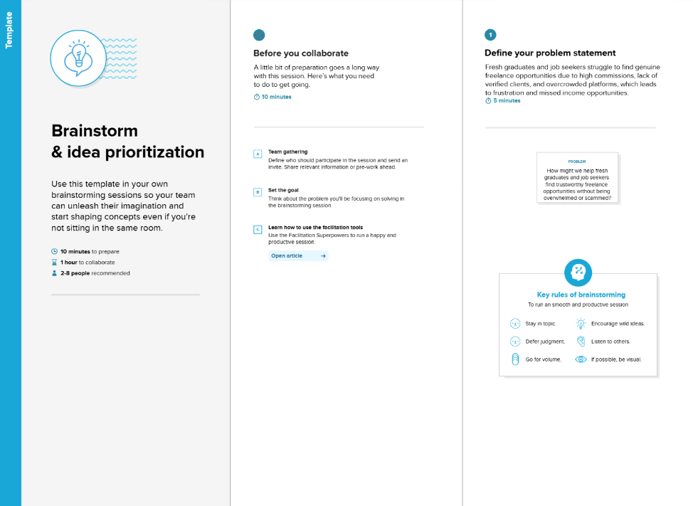
The team conducted a collaborative discussion to identify real-world problems faced by readers, book sellers, and administrators in traditional and online book-selling platforms. Key challenges identified include:
- Difficulty in managing books and orders efficiently
- Limited platforms that support multiple user roles (User, Seller, Admin)
- Lack of centralized dashboards for managing products and transactions
- Poor user experience in discovering and purchasing books
Problem Statement:
To design and develop a user-friendly, secure, and scalable online bookstore platform that allows users to browse and purchase books easily, enables sellers to manage their inventory, and allows administrators to oversee the entire system efficiently.

Step 2: Brainstorming, Idea Listing, and Grouping
During brainstorming, the team generated multiple ideas and grouped them based on functionality and relevance.
Ideas Generated:
- User authentication and role-based access
- Book browsing with category filtering
- Search functionality by title, author, or genre
- Wishlist management
- Cart and checkout system
- Dummy payment integration
- Order history tracking
- Review and rating system
- Seller dashboard for managing books
- Admin panel for user and seller control
- Image upload for book covers
Idea Grouping:
User Features
- Browse books
- Add to cart and wishlist
- Place orders
- View order history
- Manage profile
Seller Features
- Add, update, and delete books
- View listed products
- Track orders
Admin Features
- Manage users and sellers
- View platform activity
- Monitor books and orders

Step 3: Idea Prioritization

After evaluating feasibility, impact, and importance, the ideas were prioritized as follows:
High Priority
- User authentication and authorization
- Book listing and browsing
- Cart and checkout system
- Role-based dashboards
- Order management
Medium Priority
- Wishlist functionality
- Book reviews and ratings
- Seller analytics
Low Priority / Future Enhancements
- Advanced recommendation system
- Payment gateway integration
- Real-time notifications

Final Outcome
The prioritized ideas were used to design and develop TheBookStop, ensuring a balanced focus on usability, scalability, and functionality. This structured ideation process enabled the team to transform ideas into a fully functional MERN stack application.

